**GROUP-25**

**Members:**

1. Akash Kulkarni (S20210010011)
2. Divyank Khajuria (S20210010068)

**GitHub Link : https://github.com/AkashKulkarni4444/BCI_Project**

Description of Dataset and Experiment:

**Experimental Protocol**

**Introduction**

Subjects performed different motor/imagery tasks while 64-channel EEG were recorded using the BCI2000 system ([BCI2000 website](http://www.bci2000.org)).

**Experimental Runs**

Each subject performed 14 experimental runs:

1. Two one-minute baseline runs:

- Baseline with eyes open

- Baseline with eyes closed

2. Three two-minute runs of each of the following tasks:

1. Task 1: Open and close left or right fist

2. Task 2: Imagine opening and closing left or right fist

3. Task 3: Open and close both fists or both feet

4. Task 4: Imagine opening and closing both fists or both feet

**Summary of Experimental Runs**

1. Baseline, eyes open

2. Baseline, eyes closed

3. Task 1 (open and close left or right fist)

4. Task 2 (imagine opening and closing left or right fist)

5. Task 3 (open and close both fists or both feet)

6. Task 4 (imagine opening and closing both fists or both feet)

7. Task 1

8. Task 2

9. Task 3

10. Task 4

11. Task 1

12. Task 2

13. Task 3

14. Task 4

**Data Format**

The data are provided in EDF+ format, containing:

- 64 EEG signals

- Sampled at 160 samples per second

- Annotation channel

**Annotations**

Each annotation includes one of three codes (`T0`, `T1`, or `T2`):

- `T0`: Rest

- `T1`: Onset of motion (real or imagined) of

- Left fist

- Both fists

- `T2`: Onset of motion (real or imagined) of

- Right fist

- Both feet

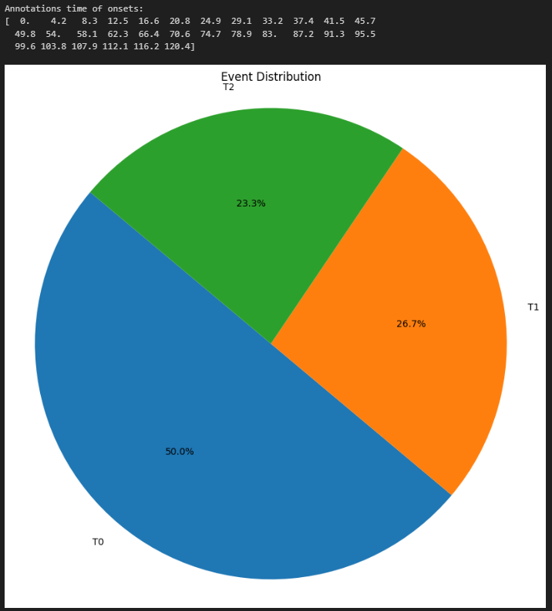Event Distribution { T0 , T1 , T2 }

Event Timeline

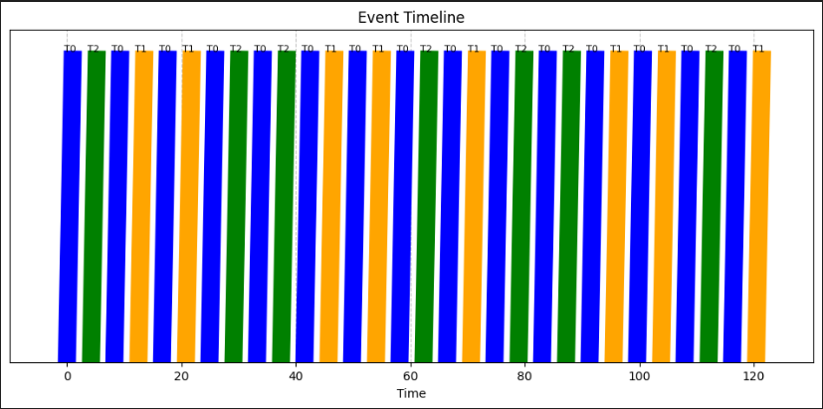

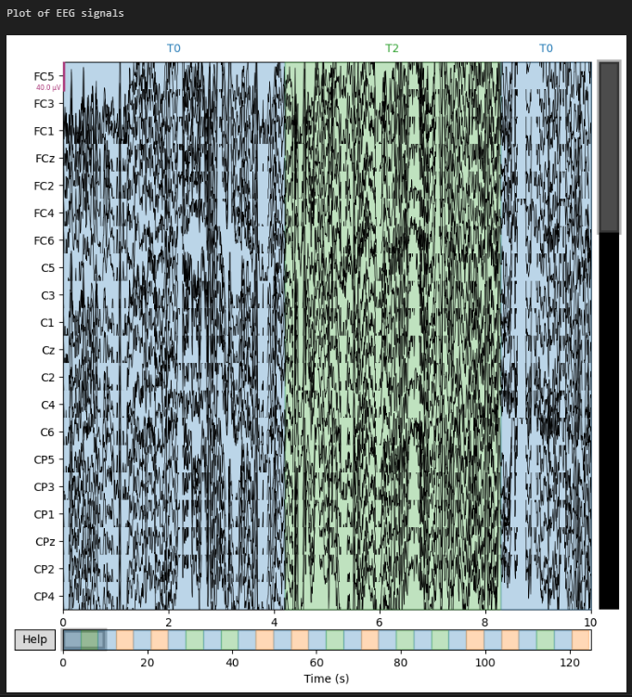Plot of EEG Signals

Plotting the Time Course of EEG

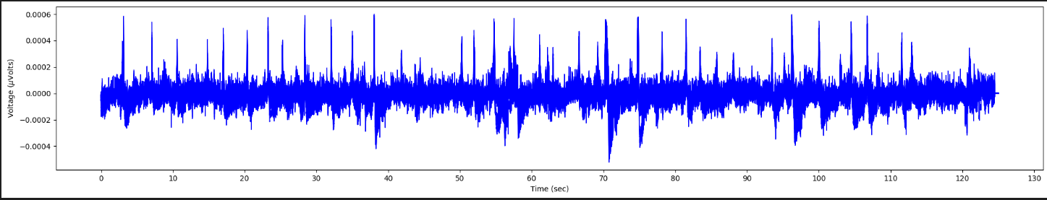

Spectrograms using STFT transform using Hann window

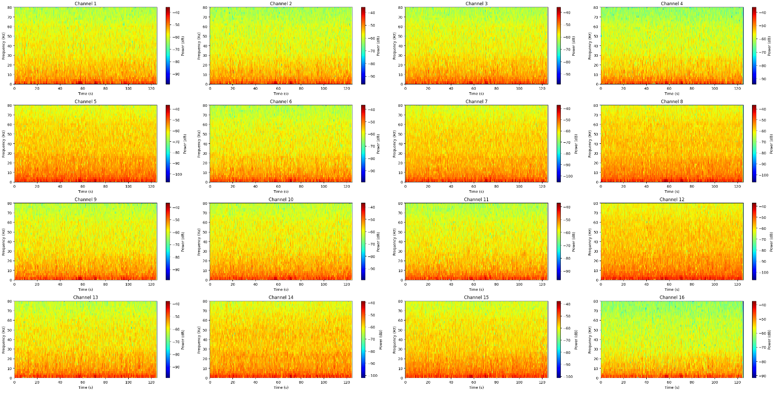

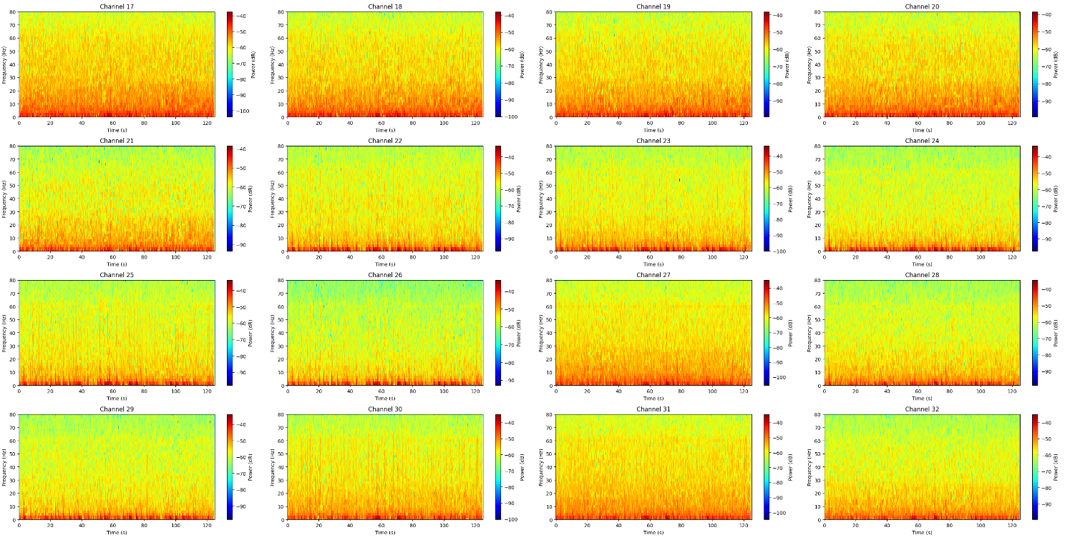

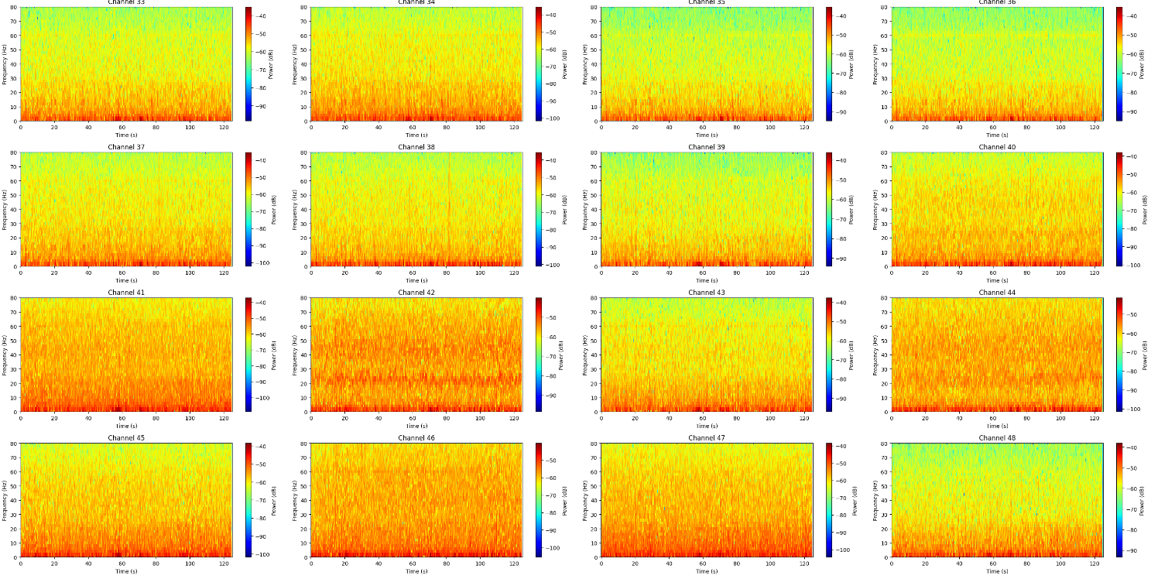

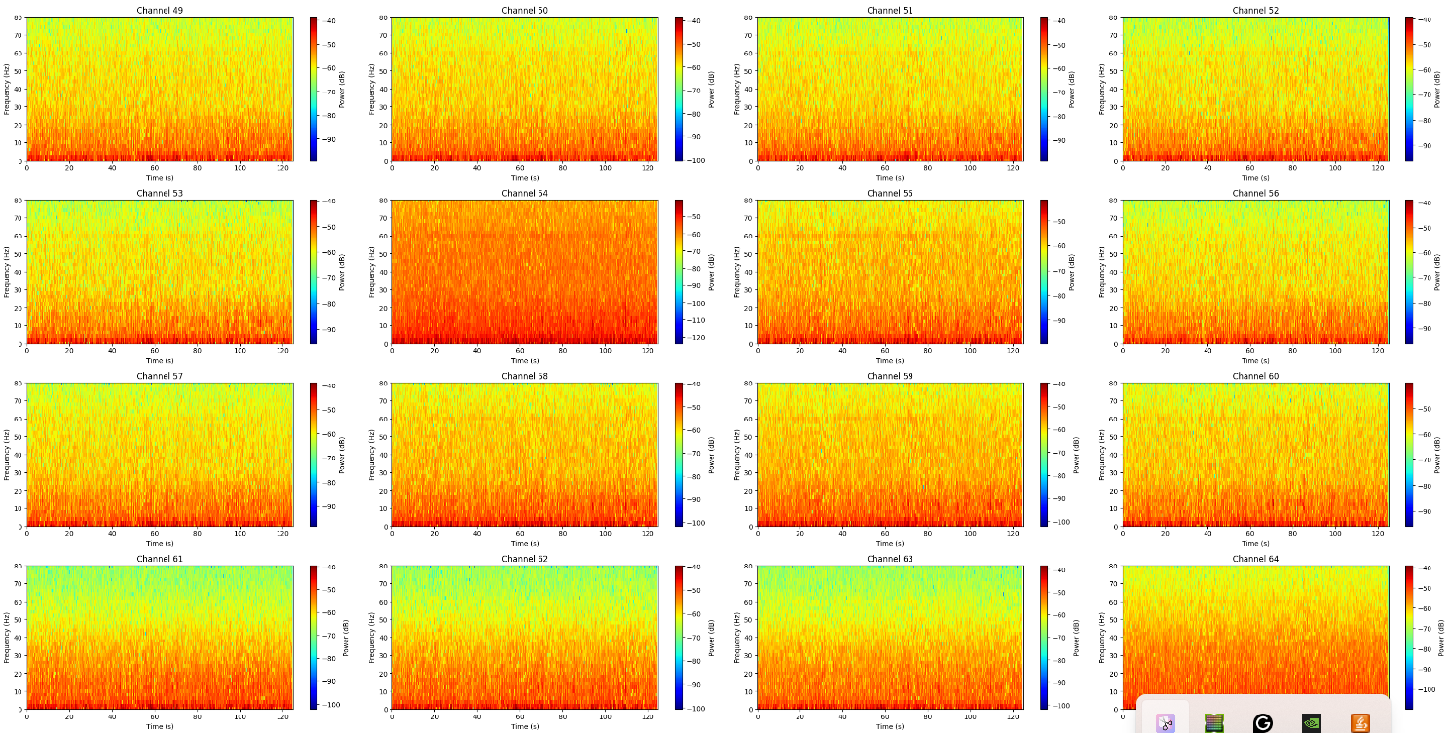

Wavelet Transforms and Visualisation of each channel

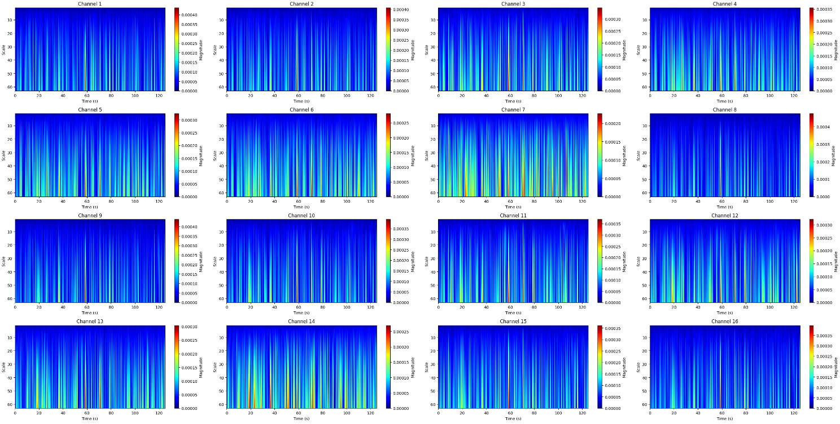

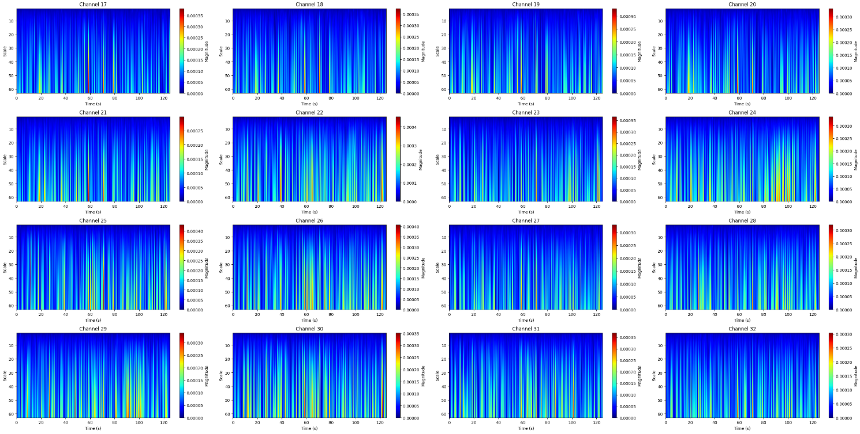

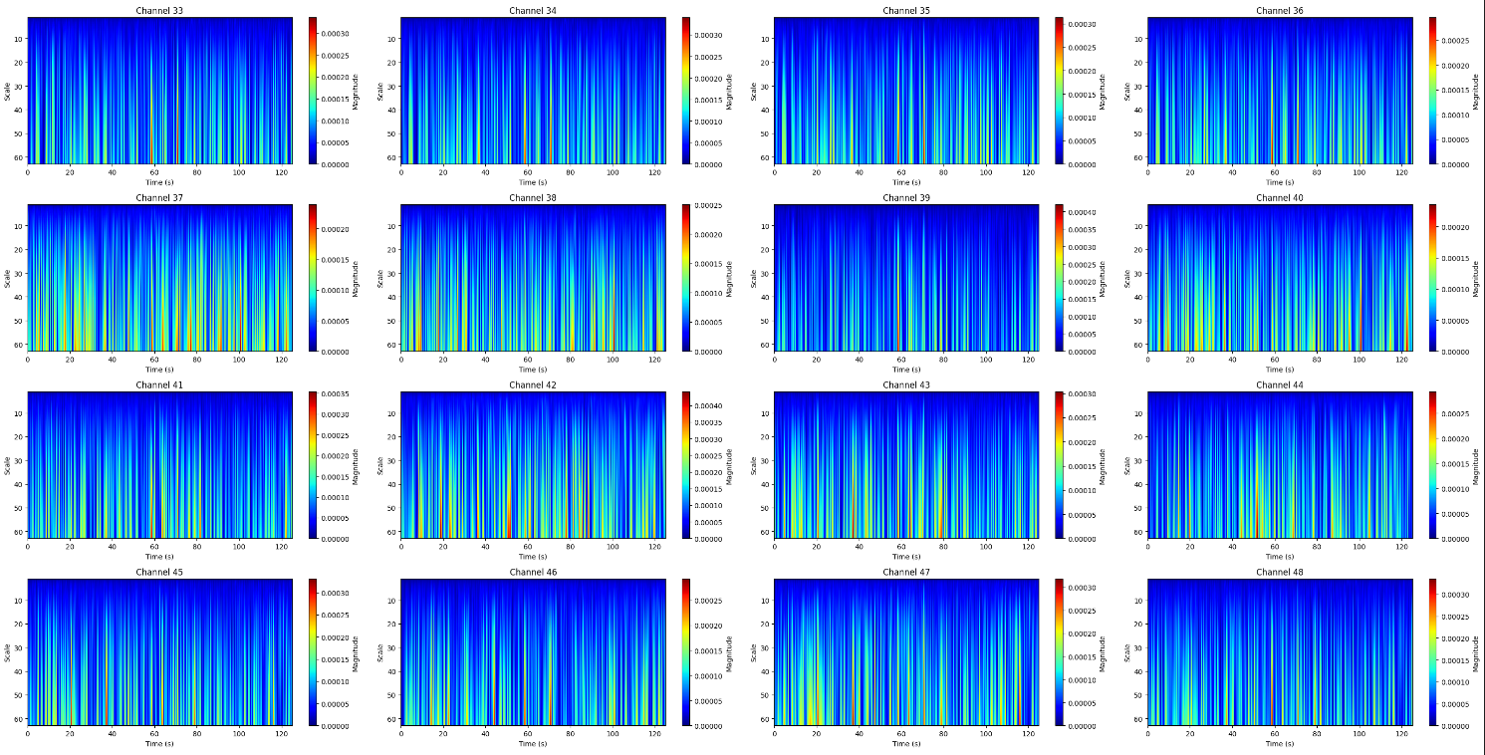

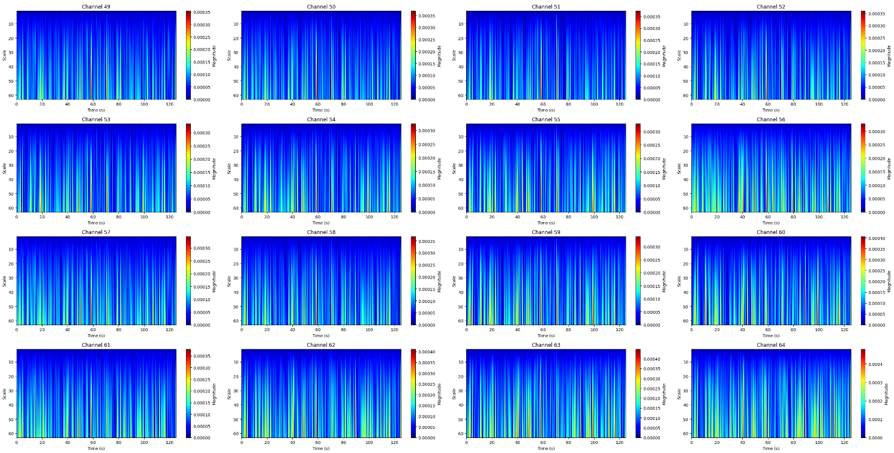

EEG plots for opening/closing of left/right fist for 1 Second

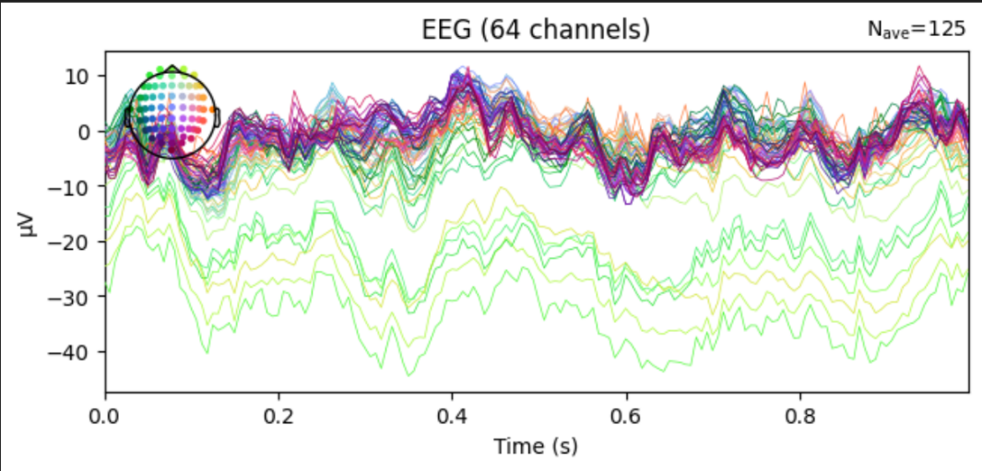

Topo Map for imagining of opening/closing of left/right fist

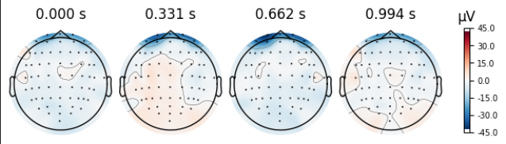

EEG plots for the 6 most significant ERP related frequencies

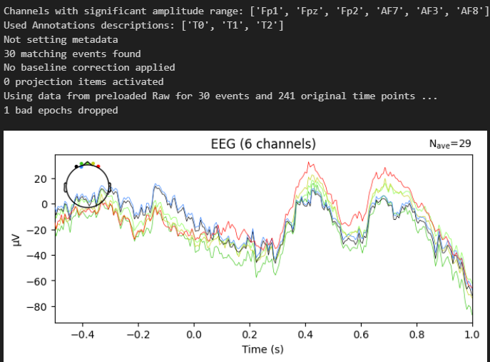

Topo Map for the 6 most significant ERP related frequencies

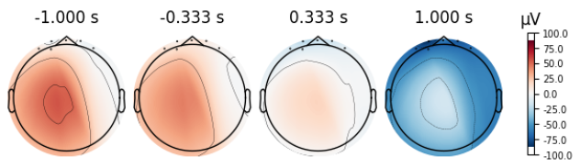

EEG Graphs for 60 seconds for

Opening/closing of left/right fist

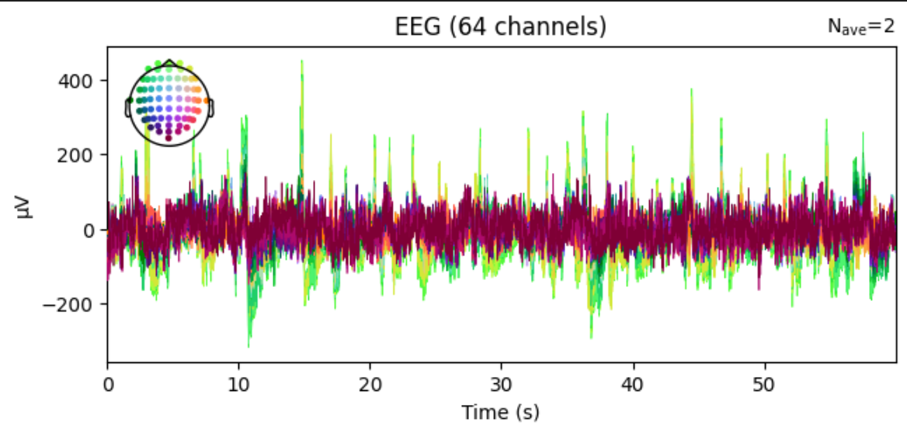

EEG Graphs for 60 seconds for imagining of

Opening/closing of left/right fist

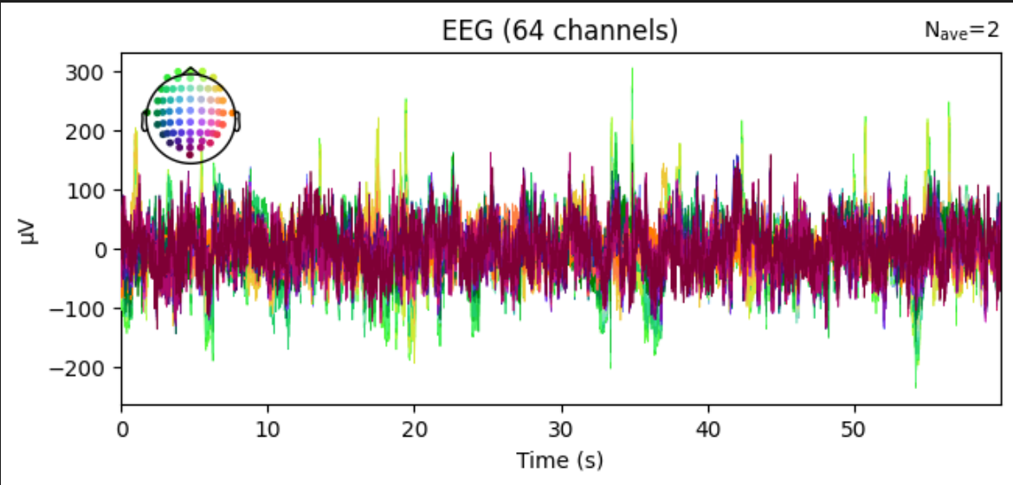

Topo Plot for opening/closing of left/right fist

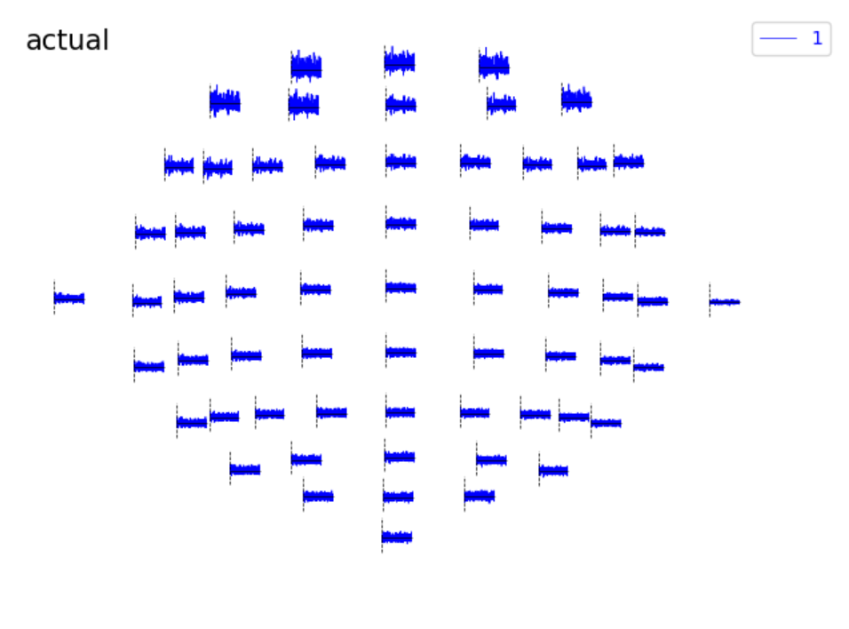

Topo Plot for imagining of opening/closing of left/right fist

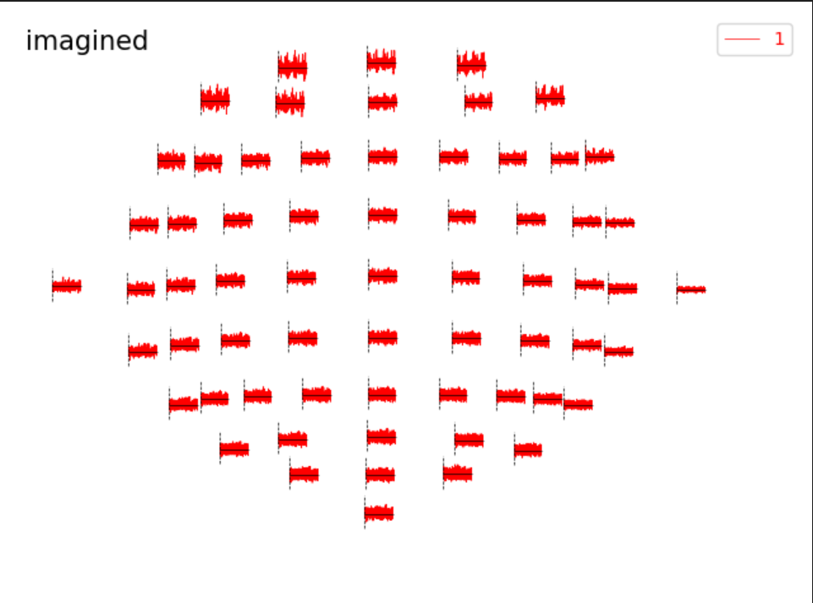

Topo Map for opening/closing of left/right fist

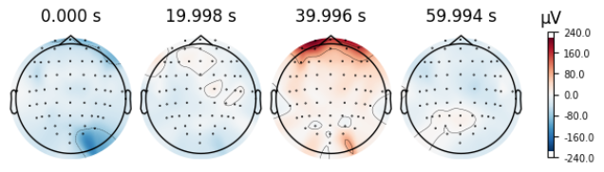

Topo Plot for imagining of opening/closing of left/right fist

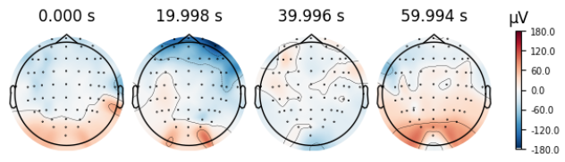

EEG data comparison between eyes open and eyes closed

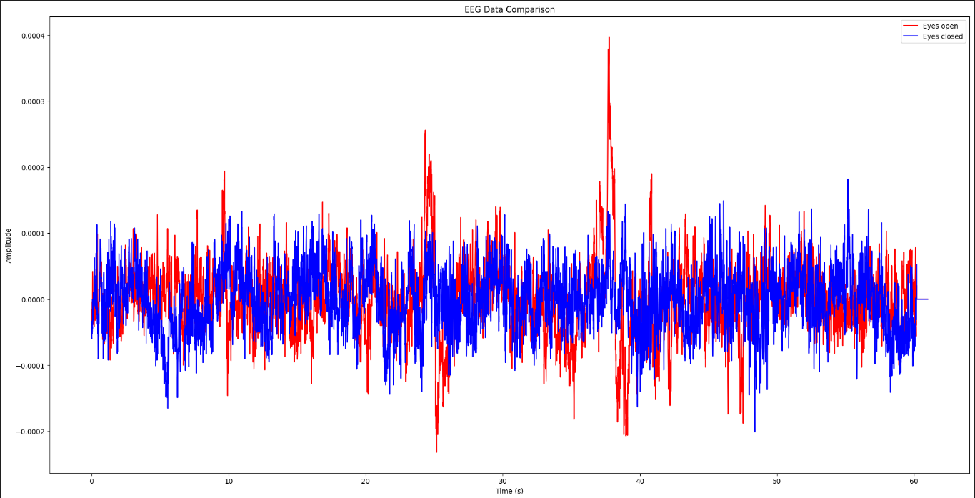

EEG data comparison between actually opening/closing of left/right fist and imagining of opening/closing of left/right fist

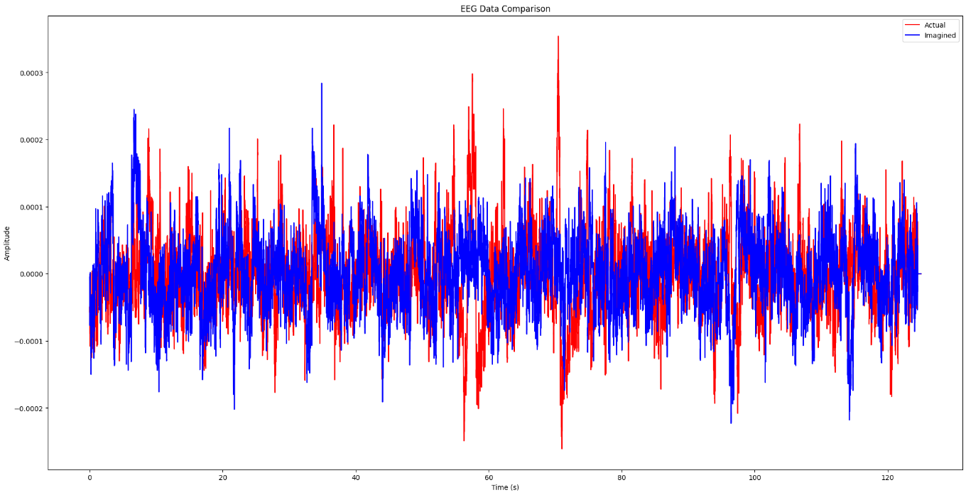

PSD plot for eyes closed

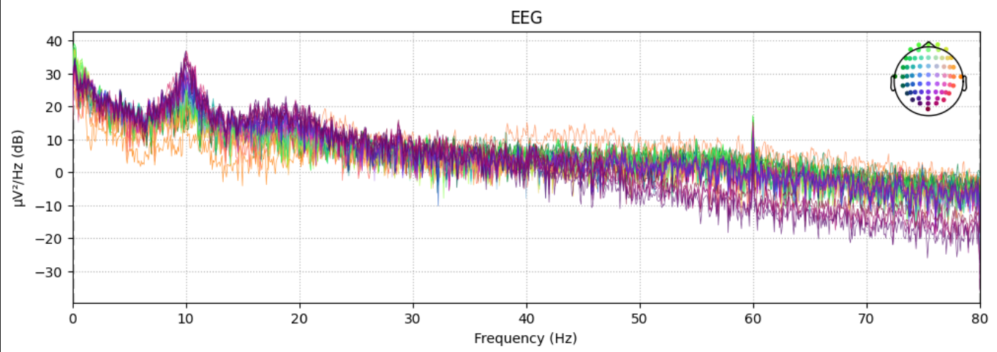

PSD plot for eyes open

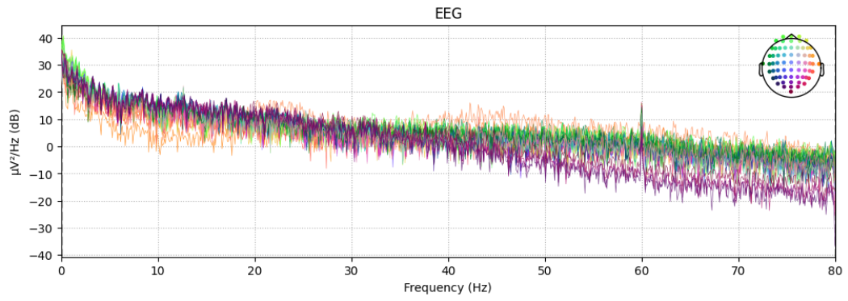

PSD plot for opening and closing of fist for all channels from FC5 to P3

